**G**

**R**

**O**

**U**

**P**

**01**



**PROPOSAL**

**Project Management System**

BUILDING & CONSTRUCTION

**Prepared F o r**

ABC Construction PVT(LTD) company

**Outline**

# ABOUT SYSTEM:

**A project management system is a digital tool designed to help individuals and teams efficiently plan, execute, and track the progress of projects. It provides a centralized platform where users can define project goals, allocate tasks, set deadlines, assign responsibilities, and monitor the overall project timeline. This system facilitates collaboration by allowing team members to communicate, share files, and update their progress in real time. Additionally, it offers features such as milestone tracking, resource management, and reporting to ensure projects are completed on time and within** **scope.**

# TOOLS:

**Visual Studio**

**Microsoft SQL Server**

**C# language**

**.net framework**







1

**Initial Plan**

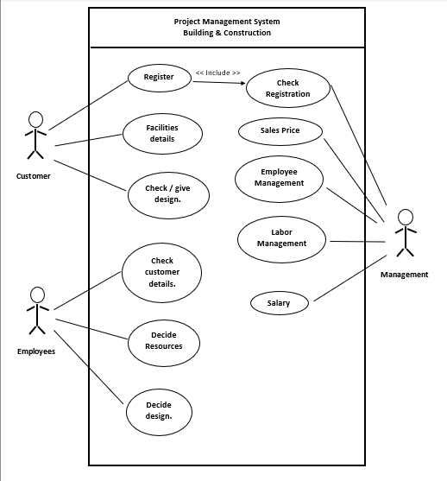

2

**Goals & Objective**

**Design and Planning:**

Develop software tools to assist architects,

and engineers in designing structures,

creating blueprints, and planning construction

projects efficiently.

**Project Management:**

Build applications for project managers to track

progress, allocate resources, and

manage budgets effectively.

**Material Management:**

Create a system for managing construction materials,

including procurement, inventory, and quality control.

**Labor Management:**

Develop tools for tracking labor, including scheduling,

attendance, and skillset management.

3



**Goals & Objective**

4

**Cost Estimation:**

Build applications for project managers to

track progress, allocate resources,

and manage budgets effectively.

**Resource Optimization:**

Develop optimization algorithms to

make efficient use of resources,

minimizing waste and costs.

**Cost Estimation:**

Build algorithms for accurate cost estimation,

taking into account materials, labor,

and other expenses.

**Progress Tracking:**

Create systems for real-time tracking of construction

progress, allowing stakeholders to monitor the project remotely.

**Safety Compliance:**

Implement features to ensure construction sites adhere to safety regulations and standards.

**Group Members**

|  |  |  |
| --- | --- | --- |
| **STUDENT NUMBER** | **NAME** | **CONTACT NUMBER** |
| PS/2019/137 | H.G.H.Eshan | 0716048560 |
| PS/2019/265 | C.P.K.Wijeratne | 0760078842 |
| PS/2019/244 | J.M.N.C.Jayamanne | 0715686673 |
| PS/2019/225 | N.P.K.D.R.S.Gunarathna | 0716964666 |
| PS/2019/022 | D.H.G.Lahiru | 0769279527 |

**Work Allocation**

|  |  |
| --- | --- |
| **CONTENT** | **TEAM MEMBER** |
| Task and Assignment | C.P.K.Wijeratne |
| Labor Management | N.P.K.D.R.S.Gunarathna |
| Employee Management | D.H.G.Lahiru |
| Progress Tracking | H.G.H.Eshan |
| Resource Management | J.M.N.C.Jayamanne |

5

**Thank You …!!!**